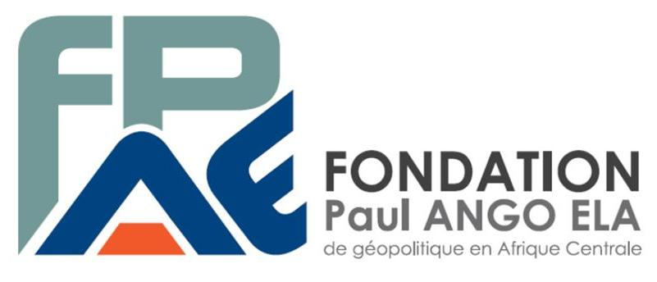

INTERNATIONAL COLLOQUIUM

History and Memory in Cameroon: Legacies and Practices
(From 1884 till now)

Proposed by the Paul Ango Ela Foundation (PAEF)

Call for Paper

Yaounde, 7-9 June 2017

“History and Memory in Cameroon: Legacies and Practices (from 1884 till now)”
Multidisciplinary International Colloquium, 7-9 June 2017 – Yaounde (Cameroon)

History in Cameroon is presented as sedimentation of memories built at different times, i.e., precolonial, colonial and contemporary. These multiple memories have been captured in an ambivalent and often contradictory manner through univocal stories, partially embedded in the country’s history. Is it therefore possible, to rewrite this history objectively today?
Of all the African countries which achieved independence through war, Cameroon remains the only country where history is still concealed. Memories of this particular era still remain traumatic and fragmented thereby depriving Cameroonians of a consensus-based history of their nation while pointing to a fundamental national issue at the same time. Prior to the mid-twentieth century – which depicted Cameroon’s political nationalism – some minor initiatives were attributed to this, but this history was not publicly acknowledged and is little known. Furthermore, the understanding of the connection between nationalism and resistance to colonization is highly controversial in Cameroon. The decolonization context, torn between proponents for independence now and those for independence later, sparked a controversy on the personalities of the “founding fathers of the nation” and makes the definition of historic figures in Cameroon quite blurry. Trapped between communitarization and the downplaying or negation of the historicity of certain figures is a looming identity crisis which questions the conditions for their resilience. The transmission of the history of these men and women responsible for shaping Cameroon echoes the prospect of the emergence of a collective memory or shared memories.
The announcement of the opening of French archives on the pre- and post-colonial period in Cameroon is an opportunity to revive the debate on historiography, against the backdrop of the challenges of conservation and the popularization of archives. The revival of historical schools offers new global or specific interpretations which are most likely to offer a more adequate methodology and tools to produce an account of Cameroon’s contemporary history.
As a result, this colloquium on the link between archives, memory and history seeks to take stock of the level of brainstorming and investigation reached so far in the social sciences and humanities on these issues. It aims to identify new methods, techniques and paradigms to question events, to arrive at a complex yet pedagogic understanding. The colloquium also hopes to boost scientific partnerships among institutions engaged in these brainstorming activities.
Debates will be centered on the four topics below to be engaged during thematic workshops.
1. A renewed historiography on colonisation?
This workshop will contrast the memories which Cameroonians have of the colonial era with the historical reality. Seeking how to depart from a dual reading of this era which goes far beyond a confrontation between two factions. Finding ways of formalizing the link between the pathos of reminiscences of “brutalization” and historic events. Diversifying the Cameroonian historian’s toolbox and making available new written, audio and visual archives should help develop a more comprehensive body of archives. Can historiographical progress offer a better understanding of the connection between emotion, memory and history?
2. Independence: from conflicting memories to a peaceful history
The workshop will focus on the dialectic between history and memory on decolonization, the war of liberation and Cameroon’s independence and construction. There is certainly a major controversy around independence, especially since some of the key players (or their relatives) from that time are still alive. On what grounds did this amnesia creep in, how did these memories fade away, how did they become selective and concealed? The workshop will analyze the mechanisms of memory re(de)construction and the requirements for the production of an official memory and history.
3. International perspectives on preserving memory and passing on history: converging views
Avoiding the excesses of memory challenges, “the duty of remembrance” as well as competing memories, requires one to confront the scientific and the political viewpoints. The workshop will focus on the actors and witnesses of Cameroon’s history on the one hand, and the promoters of the memories on the other hand. It reflects on the external perceptions and views of this history and most especially on the perception of neighbouring countries or that of Cameroon’s former colonial masters. How can transmission help open up new forms of storing and writing this history? Moreover, is there any willingness to pass on the history and the memories of that period today? How and through whom can we assemble memory tools, create remembrance places and times for the present and future of the country?
4. History and memory in Cameroon in an era of globalisation
By identifying the eras of exacerbated nationalism, speeches by politicians, media informants or more informal players, the workshop will shed more light on how the Cameroonian society relates with its national construction within a global context. Can history and other social sciences make any contribution with regard to keeping the excesses of public debates aloof? From which peaceful history can Cameroon project itself into globalisation and modernity? How can one encourage the development of efficient and coherent public policies in a drive to attain sustainable development which is the major challenge of the 21st century?
The conference proceedings will be published based on a reasonable shortlisting of presentations.

Proposed papers: an abstract of not more than 2,500 words in English or French, stating the author’s name and institution, to be sent to the following address: colloquefpae2017@gmail.com latest 14 February 2017.
The selection of abstracts by the scientific committee will be done latest 28 February 2017.
Send your presentations of not more than 35,000 characters (letters and punctuation) in English or French, including an abstract in English and French to colloquefpae2017@gmail.com before 30 April 2017.
Presentations not exceeding 20 minutes can be accompanied by audiovisual aids (including film, audio or picture archives).
Email us at: coordo.fpae@yahoo.fr , kalliopiangoela@yahoo.fr

Keywords: memory, history, archives, colonisation, independence, Cameroon, resilience, identity, globalisation, public policy.

Abstract:
This colloquium aims at assessing the link between memory, archives and history in Cameroon. The history of Cameroon is presented as a sedimentation of memories developed at different eras and captured in an ambivalent and often contradictory manner through univocal stories, partially embedded in the country’s history. Whether owing to communitarisation, the downplaying or denying of the historicity of certain figures or events, identity remains a vexed issue. It is therefore imperative to set out new paradigms and to propose requisites for resilience and an objective re(writing) of history.
Presentations and discussions will focus on the following four topics to be engaged during thematic workshops:

1. A renewed historiography on colonisation?
2. Independence: from conflicting memories to a peaceful history
3. International perspectives on preserving memory and passing on history: converging views
4. History and memory in Cameroon in an era of globalisation

